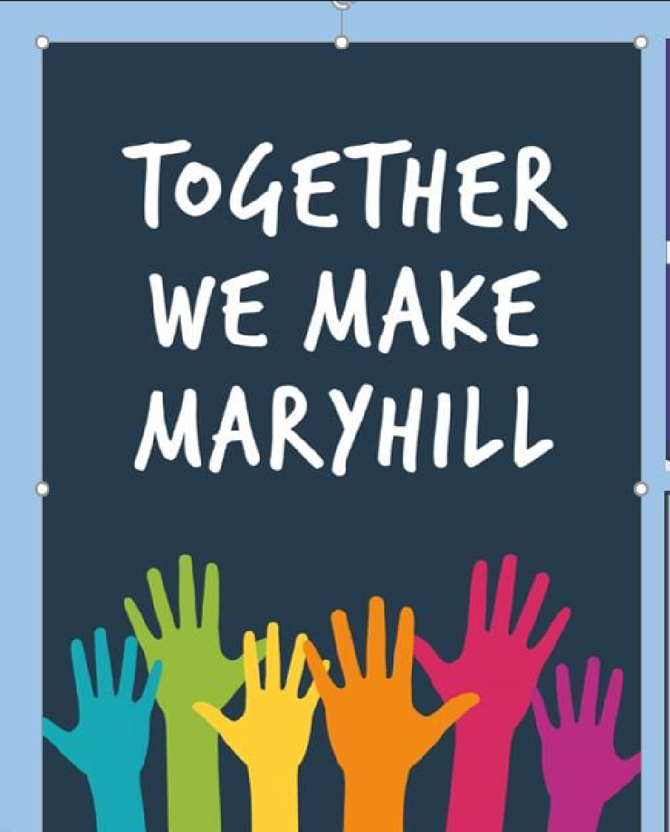
TOGETHER WE MAKE MARYHILL - JOB DESCRIPTION

COMMUNITY OUTREACH WORKER

Responsible To: Parish Minister, Maryhill Ruchill Parish Church (Line Manager)
Parish Priest Immaculate Conception Church

Background to the Post

Together We Make Maryhill (TWMM) is a successful and innovative partnership between Maryhill Ruchill Parish and the Immaculate Conception Parish. It is now in its fourth year.

The initiative developed to combat the social isolation and loneliness suffered as a result of Covid, by enabling the two churches to work together to increase their reach and support many more people. It brings people together to strengthen connections in communities and empower people by offering them opportunities to build their confidence and skills.

Our Community Outreach Worker left the post at the end of 2025 and we are seeking a successor to continue this vital role in the TWMM.

Purpose of the Post

The outreach worker will work as a member of the ministry team to develop the TWMM project further, working primarily with the two congregations and supporting a range of initiatives, to
- Coordinate activities
- Support and grow our base of volunteers
- Work directly with young people, and
- Develop new activities.

Main Duties

- As part of a team, to contribute to a strategic overview, ideas and commitment to existing projects, and to help formulate and direct emerging ones.

- To reduce social isolation in the community, particularly among older people, through providing an increase in opportunities to take part in socializing, development and growth (e.g. the Warm Welcome cafes).
- To take an active role in the development of opportunities for children and young people, including working with activities already in place; to play a leading role in the planning and running of holiday clubs.
- To take an active part in the life of the two churches, offering hospitality and attending (and where possible leading) ecumenical retreats and acts of worship - and thus be a valued member of the combined? church community.
- To support and enable volunteers of all ages to participate in a variety of settings, both church and non-church, as a way of becoming? a visible presence in both the church and community.
- To ensure a programme of training for volunteers (e.g., Health & Hygiene, Health & Safety, First Aid) and to create more volunteering experiences for people of all ages, increasing their confidence and their employability.

Other Duties

- To participate in applying for funding to assist with the growth of activities; to conduct evaluations and provide reports to funders.

- As part of a team, to develop a communications strategy; to maintain an online presence, and manage a database on behalf of both congregations, ensuring compliance with all regulations fitness for purpose.

- To participate in continuing professional development.

- To undertake such as other duties as required by line manager.

Person Specification
Skills, Abilities and Experience | Essential | Desirable
Understanding of community-based issues within an area of multiple deprivation and ability to relate to those who face these issues | √
Experience in managing or working with volunteers | √
Proven ability to work collaboratively with colleagues and contribute to effective team working | √
Willingness and proven ability to work in different ways and try new initiatives | √
A commitment to the welfare of young people and families, those in senior years and those on the margins of society | √
Proven skills in planning, implementation, monitoring, evaluation and reflective practice | √
Experience in community engagement with an asset-based approach | √
Ability to communicate effectively with others using highly developed oral and written interpersonal skills, including report writing | √
An understanding of the need to provide holistic care for a person’s wellbeing. | √
Experience in leading worship in small groups and larger gatherings. |  | √
Excellent ability to prioritise work and workload | √
Excellent IT skills to fulfill general administrative duties | √
Experience of working in the third sector |  | √
Experience of applying for external funding | √
Personal Qualities | Essential | Desirable
Committed Christian with a live Church connection and a lively Christian faith, which is a Genuine Occupational Requirement in terms of the Equality Act 2010 | √
Able to show through life, work and witness the rewards, challenges and joys of a life lived in the Christian faith, and to help others discover such a life for themselves. | √
Ready to attend worship with both the Immaculate Conception and the Maryhill Ruchhill congregations, to support those seeking to become part of either faith community | √
Able to build strong, trusting relationships with people of all ages | √
Confident to connect with outside agencies and establish a collaborative approach | √
Able to take a flexible approach to working hours
Educational Requirements | Essential | Desirable
Qualified to SCQF level 9, or similar, or accredited training in Community Work / Community Development |  | √
On-going commitment to continuing professional development including willingness to work towards qualifications and accredited training. | √
Applications will be assessed in respect of the above criteria.

Terms and Conditions

- This is a 0.5FTE Part Time role (17.5 hrs per week), initially for 1 year. TWMM will be pursuing additional funding to upgrade the post to full-time (35 hrs per week) if funding is secured.

- The nature of the work calls for a degree of flexibility, thus hours of work may vary from day to day. Some evening and weekend work will be required.

- The salary is equivalent to the Church of Scotland MDS scale, from £30,274 – £34,224 pro rata, with initial placing on the scale depending on qualifications and experience.

- We are also prepared to consider graduate applicants who have not yet had experience but are seeking a post of this kind. In that case the pay for the first year would be the National Living Wage, with the opportunity to progress to the MDS scale for a second year depending on performance, if funding is secured.

- There are 5 weeks pro rata paid leave in each full holiday year which runs from 1 January to 31 December. Entitlement is based on full weeks worked. There are also 9 pro rata statutory holidays.

- The employer is Maryhill Ruchill Church and this role is subject to Church of Scotland Safe Recruitment procedures, including PVG checks, reference checks, and safeguarding training.

- In order to comply with the Asylum and Immigration Act 1996, the successful applicant will be asked to provide document(s) confirming their eligibility to work in the United Kingdom

- Agreed expenses will be paid, including travel expenses by public transport or by use of own car at current rates.

